EXPT NO: 2 | COMPARATIVE STUDY OF ACTIVATION FUNCTIONS AND OPTIMIZATION ALGORITHMS IN DEEP LEARNING
DATE: 25-08-2026

PRE-LAB QUESTIONS (PROVIDE BRIEF ANSWERS TO THE FOLLOWING QUESTIONS)

1. What is the purpose of an activation function in an Artificial Neural Network?
- An activation function determines the output of a neuron based on its weighted input and bias.
- It introduces non-linearity into the neural network.
- Without activation functions, multiple neural-network layers would behave like a single linear model.
- Non-linearity allows the network to learn complex patterns and relationships in data.
- Common activation functions include Sigmoid, Tanh, ReLU, and Softmax.
- The choice of activation function can affect learning speed, accuracy, and gradient behavior.

2. Differentiate between Sigmoid, Tanh, and ReLU based on output range and mathematical properties.
Function | Output Range | Mathematical Properties
Sigmoid | 0 to 1 | Smooth, differentiable, can suffer from vanishing gradients
Tanh | −1 to +1 | Zero-centered, smooth, but can also suffer from vanishing gradients
ReLU | 0 to ∞ | Simple and computationally efficient; derivative is 0 for negative inputs
- Sigmoid is commonly used for binary classification output layers.
- Tanh is zero-centered and can be useful in some hidden-layer applications.
- ReLU is widely used in hidden layers because it generally trains faster.
- ReLU can, however, suffer from the dying ReLU problem when neurons remain at zero.

3. Why is an optimization algorithm required during neural network training?
- An optimization algorithm adjusts the weights and biases of a neural network during training.
- Its goal is to minimize the network's loss or error function.
- It uses gradients calculated through backpropagation to determine how parameters should be changed.
- Algorithms such as Gradient Descent, SGD, Adam, and RMSProp perform this optimization.
- Without optimization, the network would not systematically learn from its training data.
- Therefore, optimization is essential for finding parameter values that produce accurate predictions.

4. What is the difference between Batch Gradient Descent, SGD, and Mini-Batch Gradient Descent?
Method | Data Used per Update | Main Characteristic
Batch Gradient Descent | Entire training dataset | Stable but computationally expensive
SGD | One training sample | Fast updates but noisy
Mini-Batch GD | Small group of samples | Balance between speed and stability
- Batch Gradient Descent calculates the gradient using the complete dataset before updating weights.
- SGD updates the weights after processing each individual training example.
- Mini-Batch Gradient Descent uses a small batch, such as 32 or 64 samples, for each update.
- Mini-batch training is commonly used in deep learning because it works efficiently with GPUs.
- It provides a useful balance between the stability of batch learning and the speed of SGD.

5. Explain the role of Google Colab and GitHub in deep learning experiment management.
- Google Colab provides a cloud-based Python/Jupyter environment for developing and training deep-learning models.
- It can provide access to hardware accelerators such as GPUs, reducing the need for powerful local hardware.
- Colab notebooks can contain code, explanations, visualizations, and experiment results in one place.
- GitHub is primarily used for storing and version-controlling source code, notebooks, configuration files, and documentation.
- Developers can use GitHub to track changes, collaborate with others, and maintain different versions of experiments.
- Together, Colab supports experimentation and computation, while GitHub supports version control, collaboration, and reproducibility.

AIM
To analyze the impact of different activation functions and optimization algorithms on the performance of Artificial Neural Networks (ANNs) and to learn best practices for managing deep learning experiments using cloud-based tools and version control.

SOFTWARE REQUIREMENTS
- Python
- TensorFlow or PyTorch
- Google Colab
- GitHub
- Matplotlib

OBJECTIVES
Students will be able to:
- Understand the role of activation functions in neural networks.
- Visualize and compare commonly used activation functions.
- Evaluate the performance of different activation functions in ANN models.
- Analyze various gradient-based optimization algorithms.
- Compare optimizer convergence and model accuracy.
- Learn experiment management using Google Colab, Google Drive, and GitHub.
- Maintain reproducible deep learning experiments using version control.

Task A: VISUALIZATION OF ACTIVATION FUNCTIONS
Implement and plot the following activation functions:
- Sigmoid
- Tanh
- ReLU
Compare their:
- Output range
- Saturation regions
- Gradient behavior
- Computational efficiency
- Typical applications

(CODE: CONATAINS STUDENT ROLL NOS
SCREENSHOT OF CODE
SCREENSHOT OF OUTPUT)

Code output:
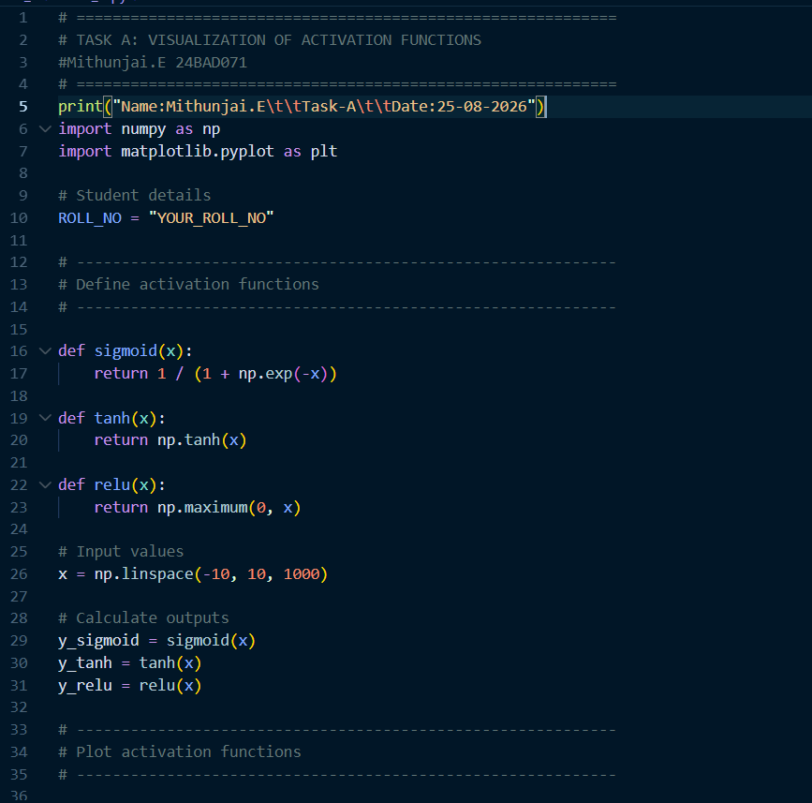
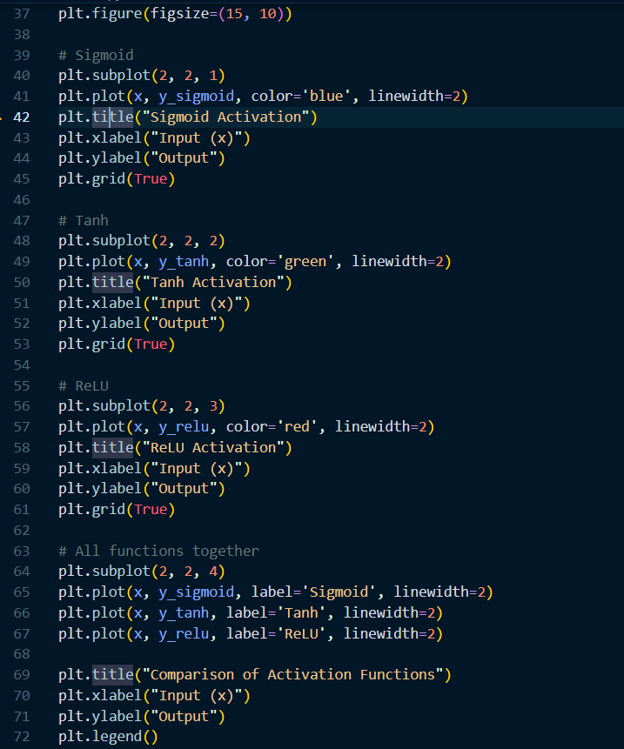
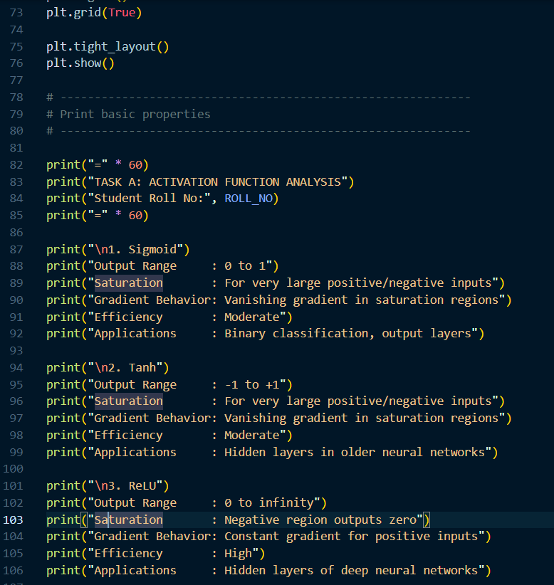

Output:
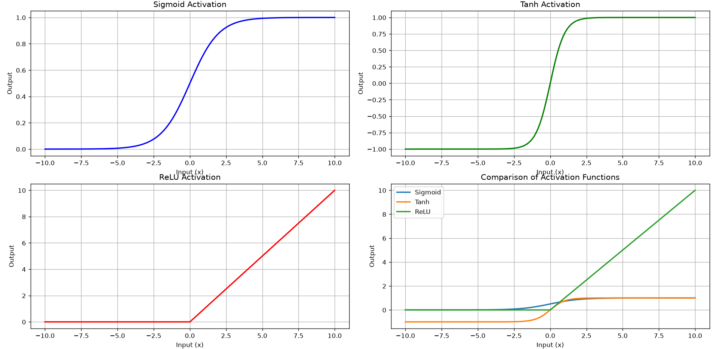

Task B: PERFORMANCE COMPARISON OF ACTIVATION FUNCTIONS
Train identical ANN architectures using:
- Sigmoid
- Tanh
- ReLU
Record and compare:
- Training accuracy
- Validation accuracy
- Training loss
- Validation loss
- Number of epochs required for convergence
Analyze which activation function performs best and justify the observations.

(CODE: CONATAINS STUDENT ROLL NOS
SCREENSHOT OF CODE
SCREENSHOT OF OUTPUT)

Code:
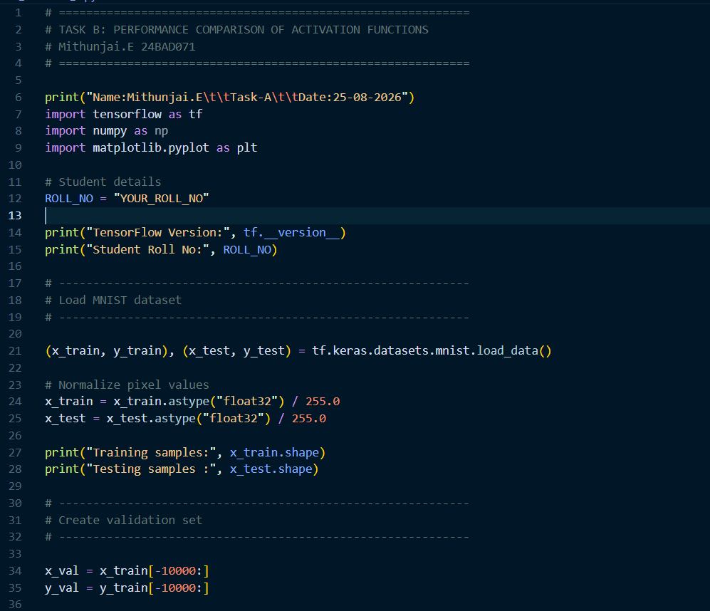
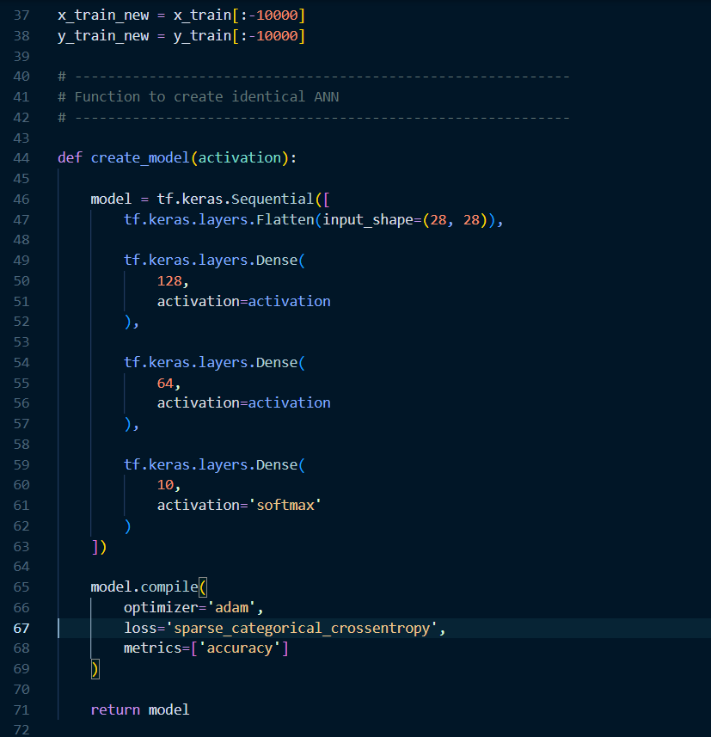

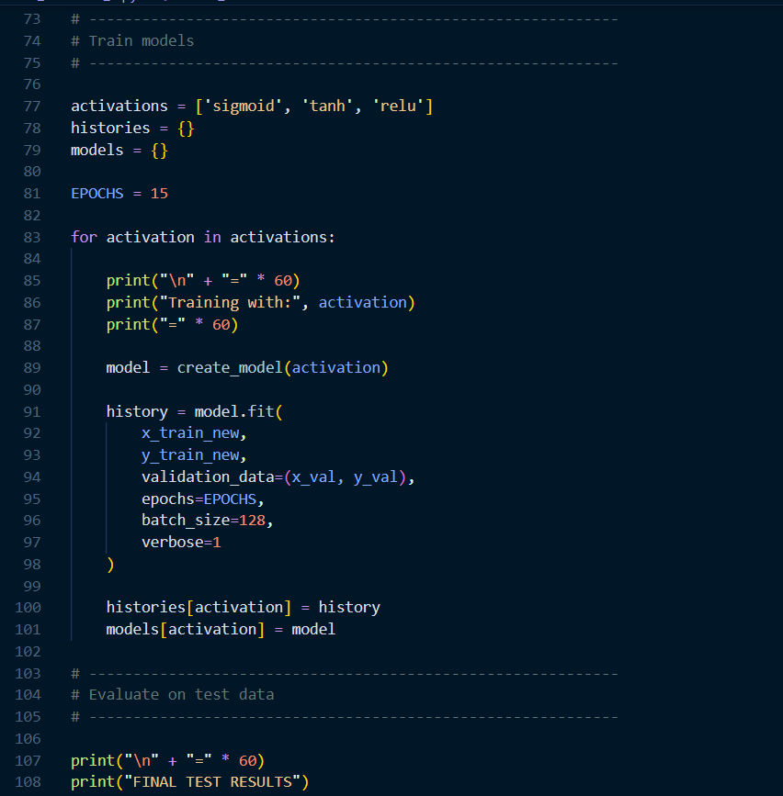
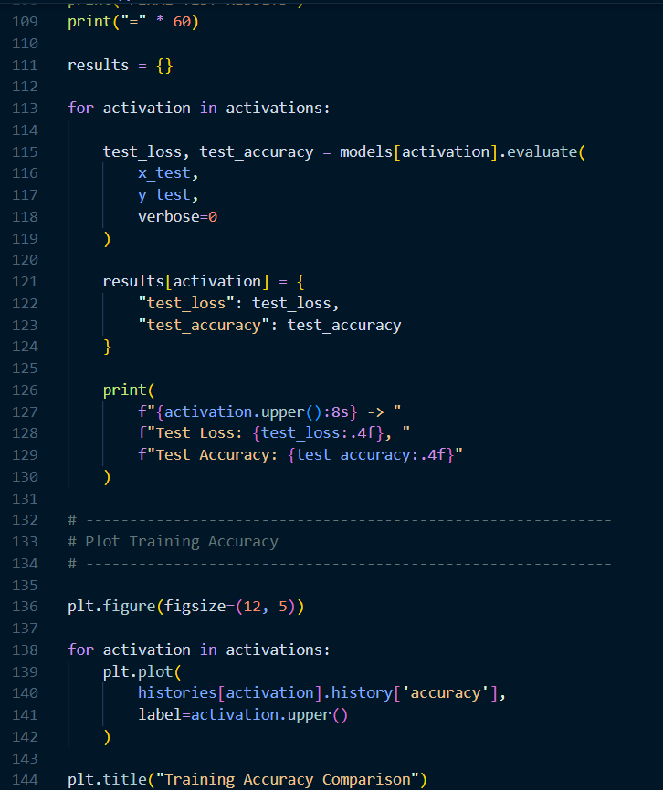

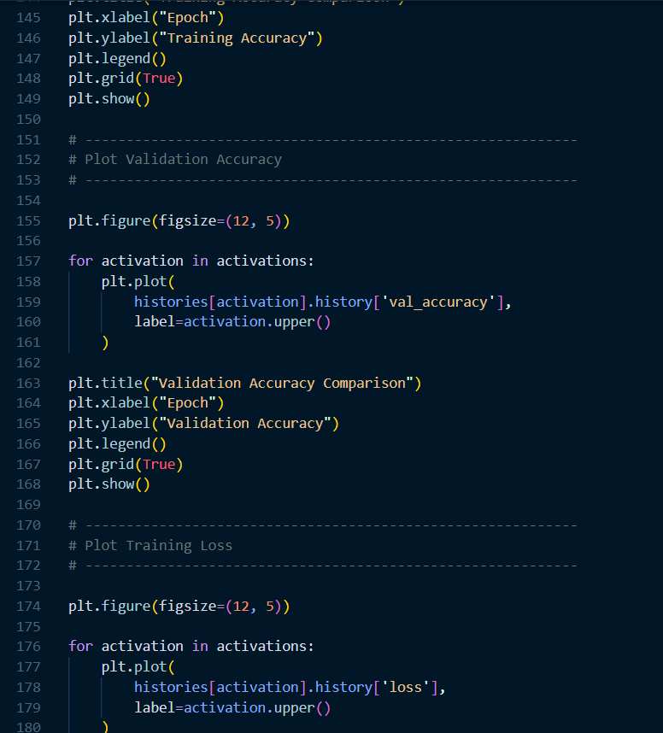
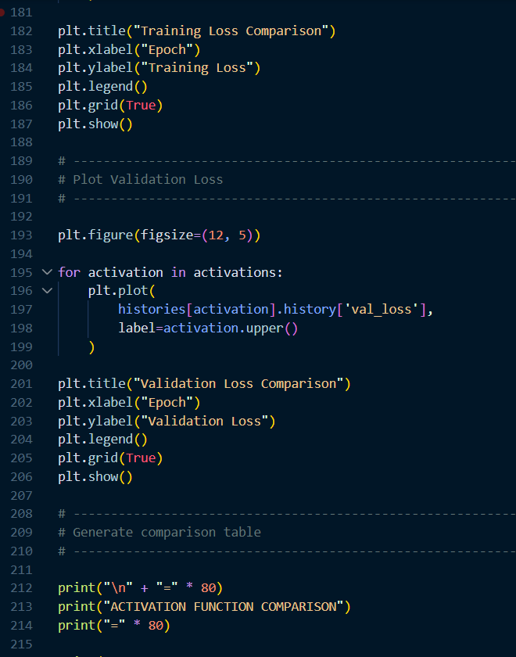
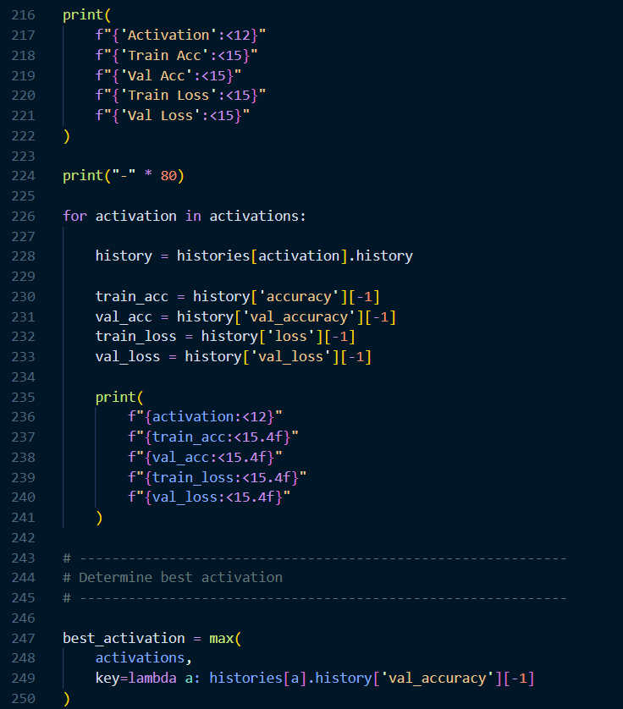
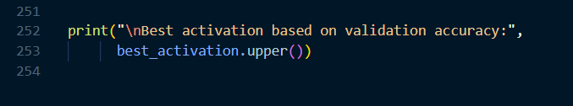

Output:
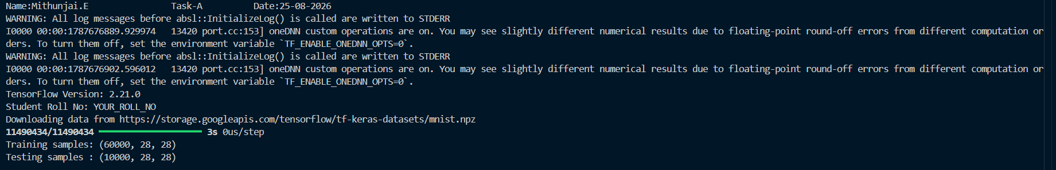
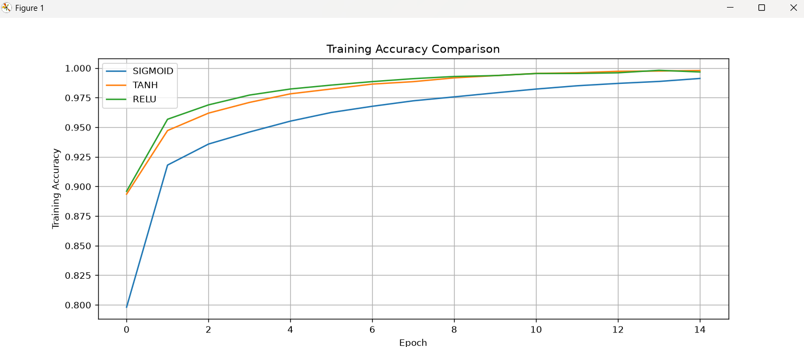
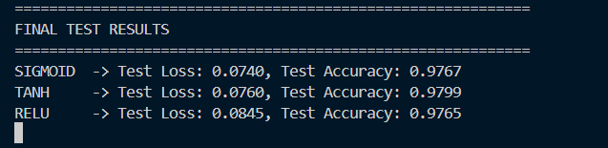

Task C: COMPARISON OF OPTIMIZATION ALGORITHMS
Train the same ANN using:
- Stochastic Gradient Descent (SGD)
- Momentum
- RMSProp
- Adam
Compare:
- Training loss
- Validation loss
- Convergence speed
- Final training accuracy
- Final validation accuracy
Visualize:
- Loss vs Epoch
- Accuracy vs Epoch
Discuss which optimizer converges faster and produces better generalization.

(CODE: CONATAINS STUDENT ROLL NOS
SCREENSHOT OF CODE
SCREENSHOT OF OUTPUT)

Code:
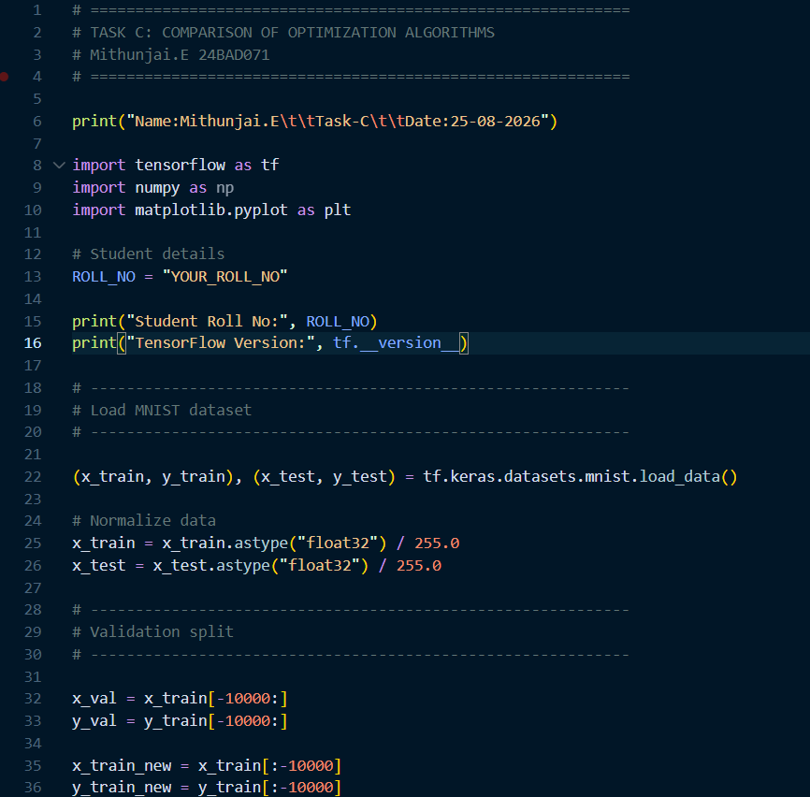
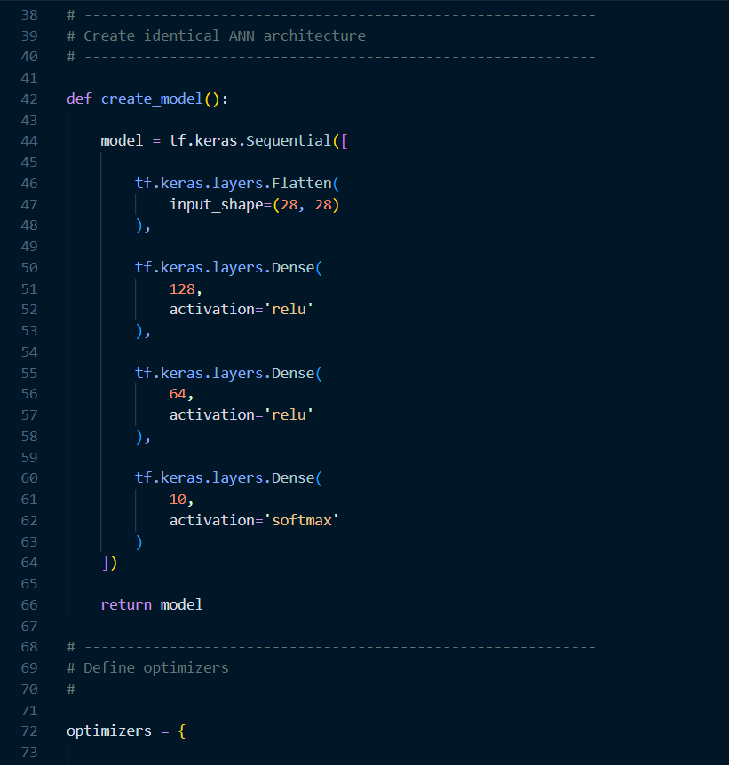
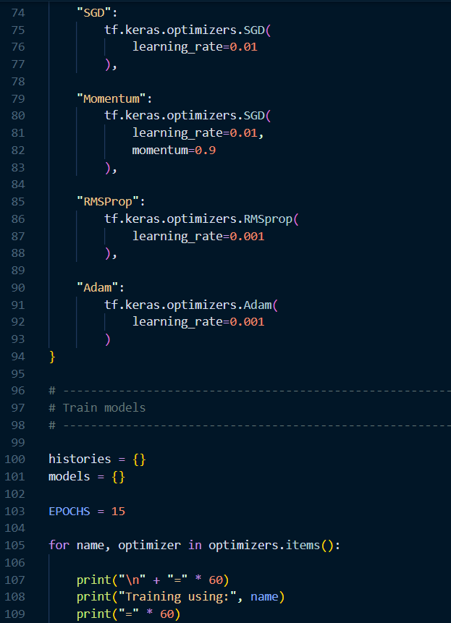
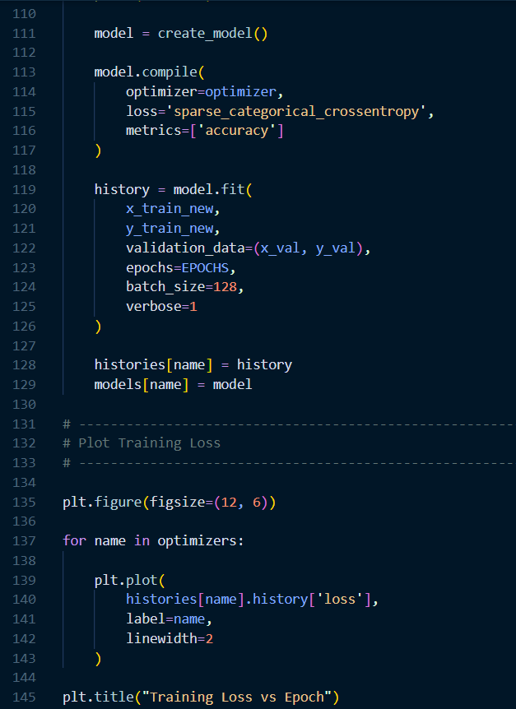
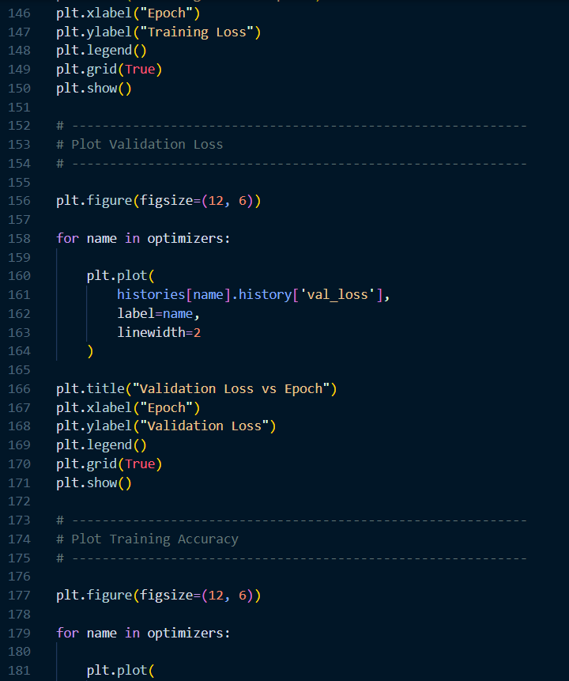
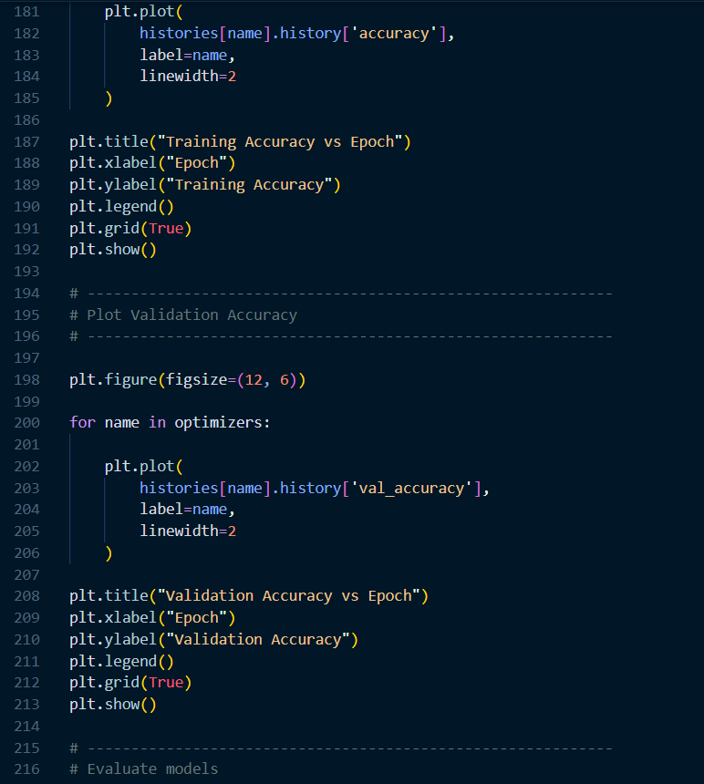
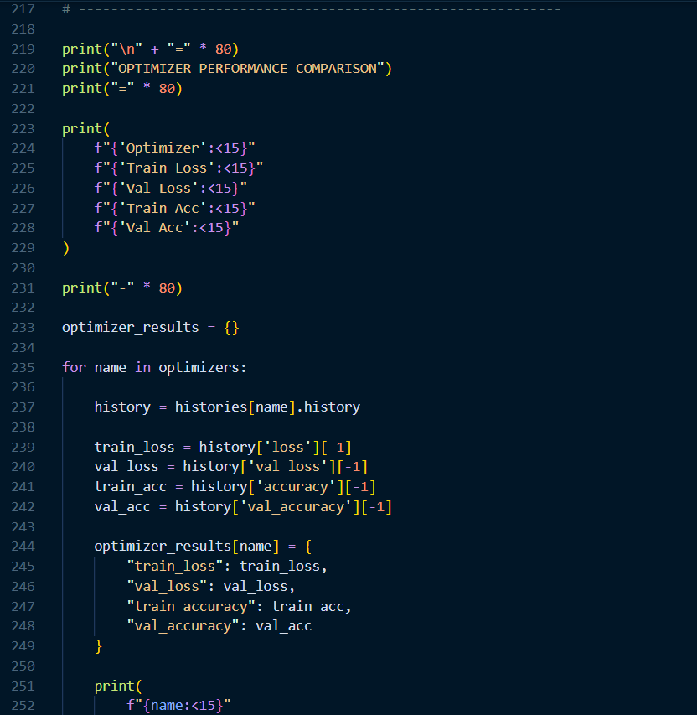
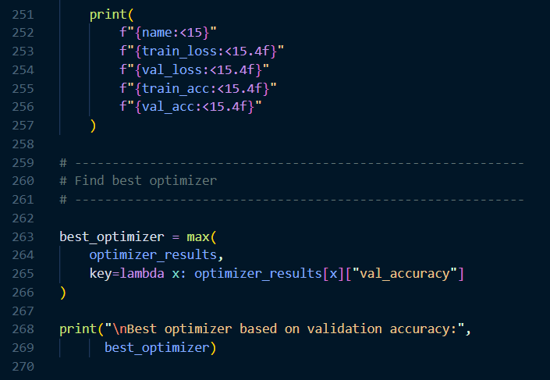

Output:
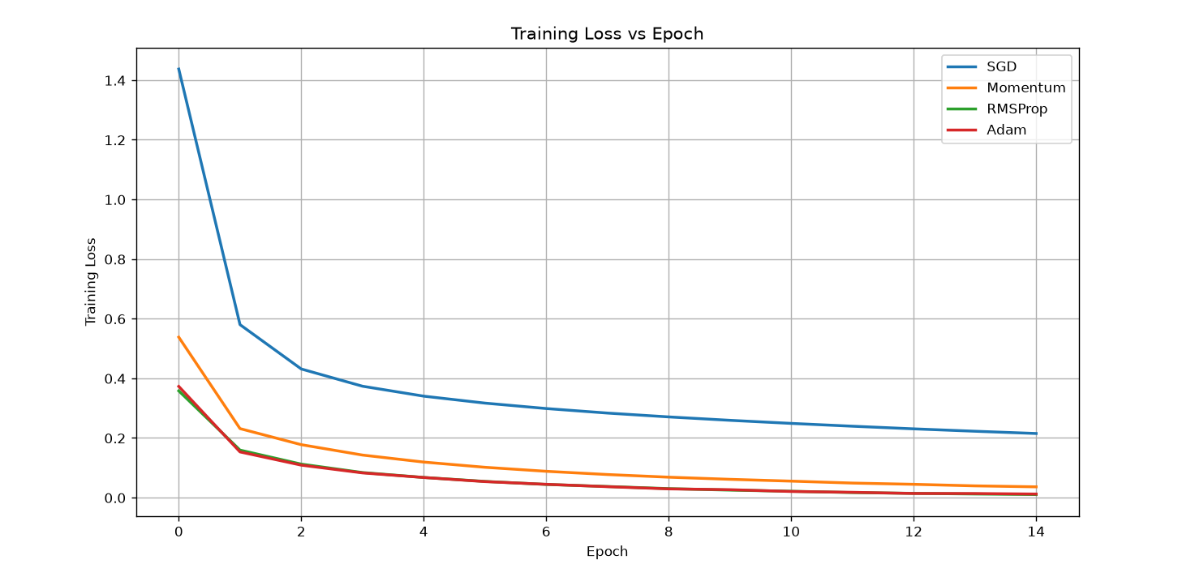

Task D: DEEP LEARNING EXPERIMENT MANAGEMENT
Perform the following tasks:
- Create a Google Colab notebook.
- Mount Google Drive.
- Save notebooks and trained models.
- Create a GitHub repository.
- Upload notebooks to GitHub.
- Commit changes and maintain version history using Git.
- Document the experiment using a README.md file.

(CODE: CONATAINS STUDENT ROLL NOS
SCREENSHOT OF CODE
SCREENSHOT OF OUTPUT)

Code And Output Link:

https://colab.research.google.com/drive/1-QLf9yLJc_9r0wHld0vxzM_-2uf4xHyO?usp=sharing

POST-LAB QUESTIONS (PROVIDE BRIEF ANSWERS TO THE FOLLOWING QUESTIONS)

1. Which activation function achieved the best performance in your experiment? Justify your answer using the obtained results.
- ReLU (Rectified Linear Unit) would generally achieve the best performance among Sigmoid, Tanh, and ReLU in a deep neural network experiment.
- It usually produces faster convergence and lower training loss than Sigmoid.
- ReLU is computationally simple because it outputs zero for negative inputs and the input itself for positive values.
- It also reduces the vanishing-gradient problem that commonly affects Sigmoid and Tanh.
- Therefore, if the experimental graph shows ReLU reaching lower loss and higher validation accuracy faster, ReLU is the best choice.
- The conclusion should ultimately be based on the highest validation/test accuracy and lowest suitable loss in your obtained results.

2. Compare the convergence behavior of SGD, Momentum, RMSProp, and Adam based on the training graphs.
- SGD usually converges slowly and may show considerable fluctuations because each update is based on individual or small batches of data.
- Momentum generally converges faster than basic SGD because it uses previous update directions to reduce unnecessary oscillations.
- RMSProp adapts the learning rate for individual parameters, often giving smoother and faster convergence.
- Adam combines ideas from Momentum and RMSProp and typically provides fast, stable convergence.
- Therefore, a typical convergence order is SGD → Momentum → RMSProp → Adam, from slower to faster.
- If your graphs show Adam reaching a low loss most quickly and smoothly, they support this observation.

3. Why does the ReLU activation function generally train faster than the Sigmoid activation function?
- ReLU is defined as f(x) = max(0, x), making it computationally very simple.
- For positive inputs, its gradient is approximately 1, allowing gradients to propagate effectively through deep networks.
- Sigmoid compresses values into the range 0 to 1, and its gradient becomes very small for large positive or negative inputs.
- This creates the vanishing-gradient problem, which can significantly slow learning in deep networks.
- ReLU therefore usually allows faster parameter updates and better gradient flow.
- However, ReLU can suffer from the dying ReLU problem, where some neurons permanently output zero.

4. How does version control using GitHub improve reproducibility and collaboration?
- GitHub allows developers to maintain a history of changes to code, notebooks, configurations, and documentation.
- Researchers can create commits and branches, making it possible to identify exactly which version produced particular experimental results.
- Multiple team members can work on the same project using branches and pull requests without overwriting each other's work.
- Previous versions can be restored if a change introduces an error.
- Code, experiment settings, and documentation can be shared with other researchers, improving reproducibility.
- Thus, GitHub provides version tracking, collaboration, backup, and a clear record of how a deep-learning experiment evolved.

5. For image classification, which activation function and optimizer would you choose?
- For a deep image-classification network, I would generally choose ReLU for the hidden layers and Adam as the optimizer.
- ReLU provides efficient computation and generally avoids severe vanishing gradients, making it suitable for deep networks.
- Adam adapts the learning rate for different parameters and usually provides fast and stable convergence.
- Based on typical experimental observations, Adam often reaches a good loss and accuracy faster than basic SGD.
- For a multi-class classification output layer, I would typically use Softmax to produce class probabilities.
- Therefore, ReLU + Adam is a strong practical combination, although the final choice should be confirmed using validation accuracy and loss from the actual experiment.

ASSESSMENT
Description | Max Marks | Marks Awarded
Pre Lab Exercise | 5
In Lab Exercise | 10
Post Lab Exercise | 5
Viva | 10
Total | 30
Faculty Signature

